

**Football Booking Ticket**

**Final Release Document**

**Hanoi, July 2024**

Prepare by:

Quách Thế Kiệt (HE172485)

Đỗ Đức Vinh (HE172487)

Đỗ Tiên Thuật (HE173070)

Trần Anh Quân (HE170941)

Nguyễn Cảnh Dương (HE173192)

– Hanoi, July 2024 –

**Table of Contents**

I. Deliverable Package 3

II. Installation Guides 3

1. Installing JDK 17 3

2. Installing Apache Tomcat 10.1.x 3

3. Installing Apache NetBeans IDE 17 8

4. Integrating Apache NetBeans IDE 17 with Apache Tomcat. 8

5. Install SQL Server 10

6. Download Github and clone Project 14

7. Open Project with Apache Netbeans IDE 17 18

III. User Manual 20

1. Overview 20

2. Purchasing Operations 20

# I. Deliverable Package

| **No.** | **File** | **Notes** |
| --- | --- | --- |
| 1 | (File RDS) | Final SRS (Requirement) Document |
| 2 | (File Project Tracking) | Project track on each iter and whole project |
| 3 | (File Present) | Project presentation of group |

# II. Installation Guides

## 1. Installing JDK 17

<https://www.oracle.com/java/technologies/downloads/>

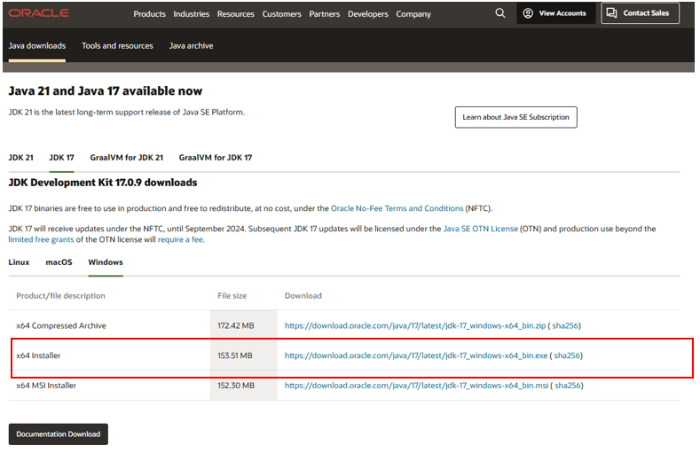

After installing, let check the installation folder:

Normally it will be located at: C:\Program Files\Java. It contains 1 folder JDK-17.

If you see these folders, it is ok for now.

For more details, you can read <https://www.oracle.com/java/technologies/javase-jdk8-doc-downloads.html>

## 2. Installing Apache Tomcat 10.1.x

Link: https://tomcat.apache.org/download-10.cgi

Open the installer file then click “Next” button, until you see the below screen:

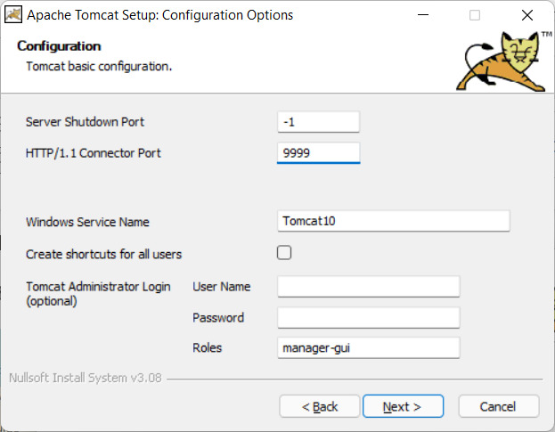

By default, the HTTP port is set as 8080, but I prefer to change it to 9999. You can keep it as 8080 or change it as you desire. Same for Window Service Name.

You can also set username and password at this step, but it is an optional and you can do it later.

Click “Next”, then the installer will ask you for JDK-17 folder. Basically, the installer can automatically detect JDK-17 folder, but in the case it cannot, you can add it manually.

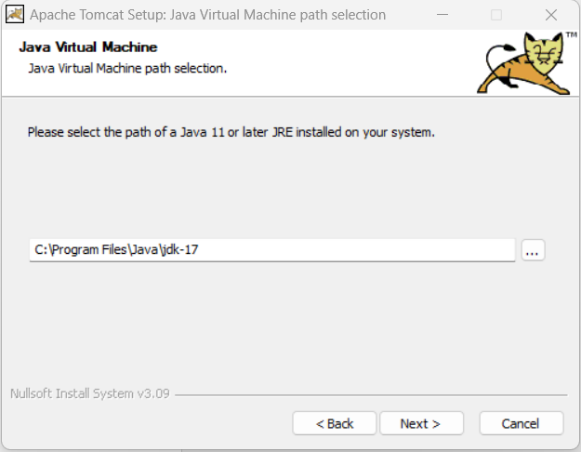

Click “Next” …. Again then “Finish”.

Normally, you are going to see the below window app displayed:

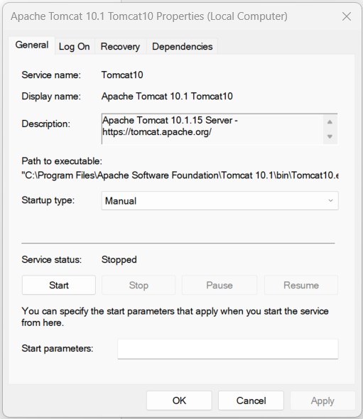

It is ok, this application used to control your TOMCAT webserver, but if you do not see it, do not worry. I recommend you follow below instructions:

1. TOMCAT now is installed as a Window Service (It is a software, but it does not have a graphic user interface).
2. To work with Window Service, press window+R, fill service.msc

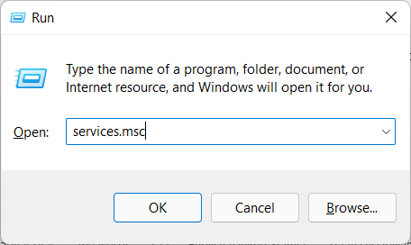

1. Find the TOMCAT service in the list:

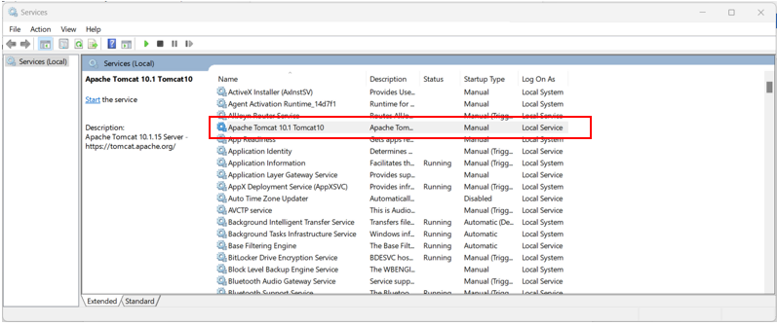

Right click -> properties ->



Now you can start/stop the TOMCAT service. Just make sure it is running before use.

You can grant permission for TOMCAT to run with Local System account on the same dialog.

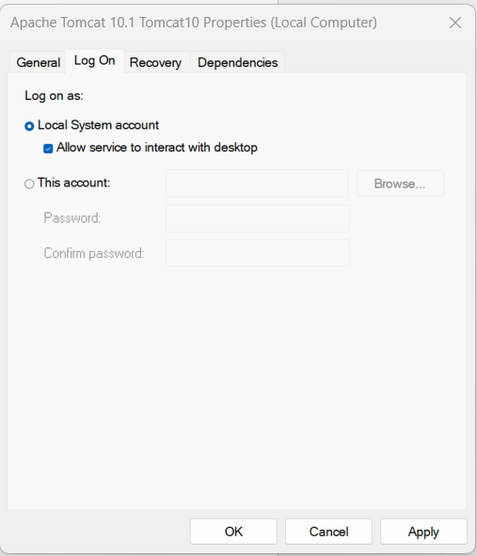

## 3. Installing Apache NetBeans IDE 17

Download: https://netbeans.apache.org/front/main/download/nb17/

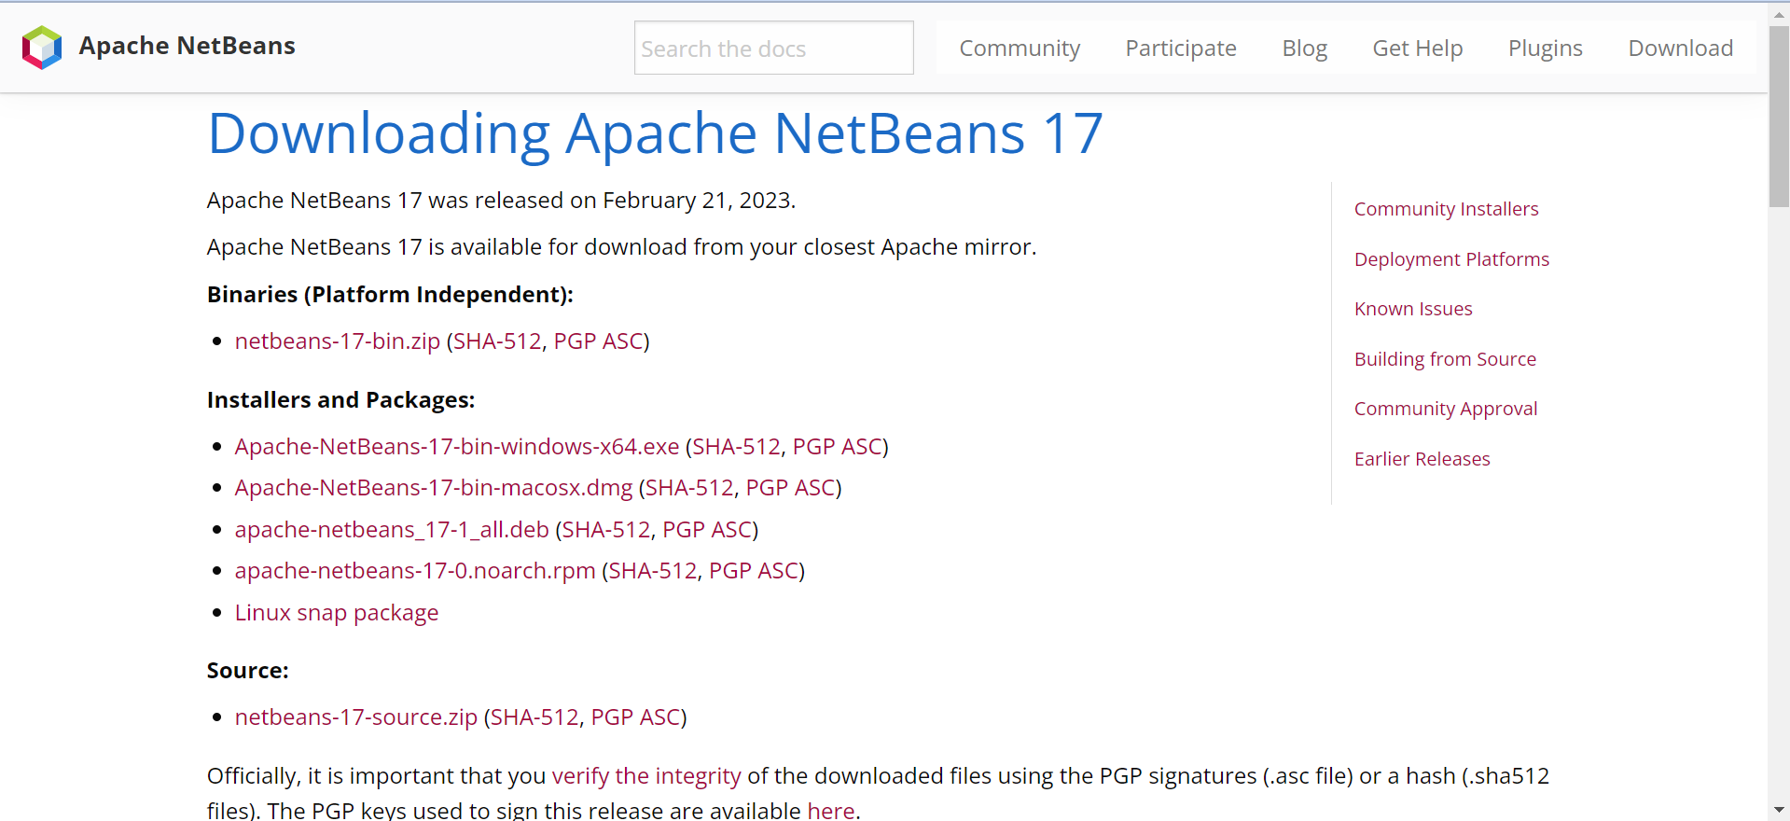

During your installation, remember to select JDK 17 (just in case, you have more than one version of Java).

After installation, run Netbeans 17, File > New Project > Java with Ant > Select Web Application (It is disabled by default, just select it, netbeans will automatically enable the project template).

## 4. Integrating Apache NetBeans IDE 17 with Apache Tomcat.

+ First, open the Apache Tomcat folder:

By default, it is located at: **C:\Program Files\Apache Software Foundation\Tomcat 10.1**

The system may ask you to grant permission, just click “Yes” button. This step aims to allows your account to access the Apache Tomcat folder for further tasks.

**+** Open Netbeans, on the menu bar, Window > Service (Ctrl + 5) > select Service panel as following:

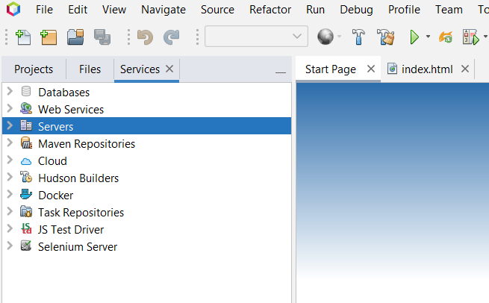

Server > Right click > Add Server > Apache Tomcat and TomEE >

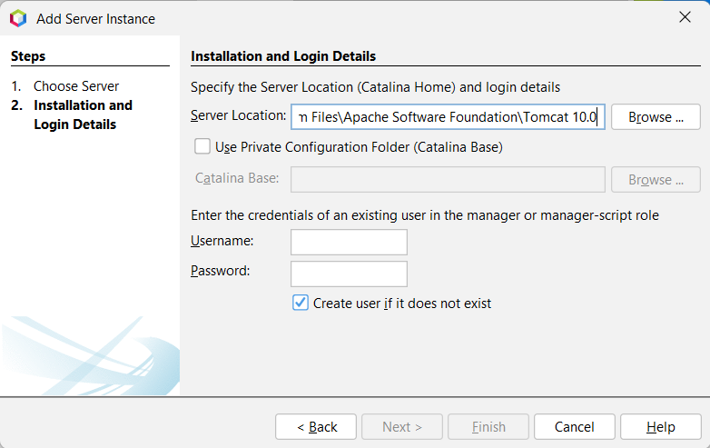

Here you can create your username and password, then finish. Now you can work with Java Web project in netbeans 17.

If you get an error related to “CATALINA_base is Invalid”, check the first step.

Errors related to Tomcat will be logged to “C:\Program Files\Apache Software Foundation\Tomcat 10.1\logs”, check the catalina**** file for the detail logs.

## 5. Install SQL Server

**Step 1:** Visit the homepage to download SQL Server 2019 [tại đây](https://www.microsoft.com/en-us/sql-server/sql-server-downloads).

Then press the download button in the developer section to download the software

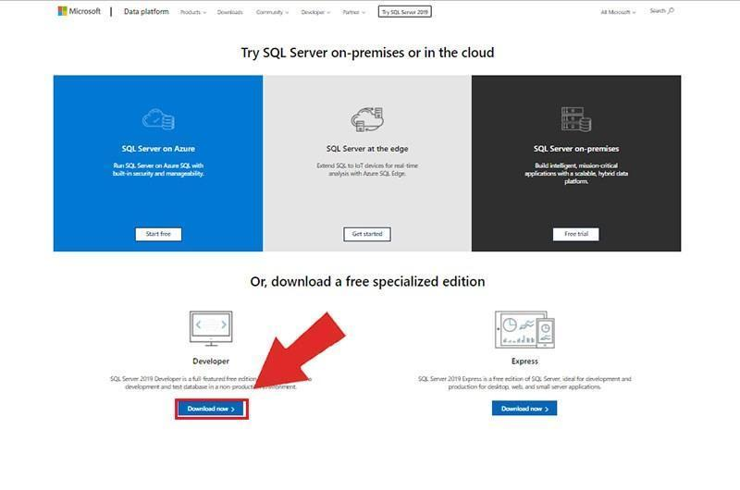

**Step 2:** Open the downloaded application

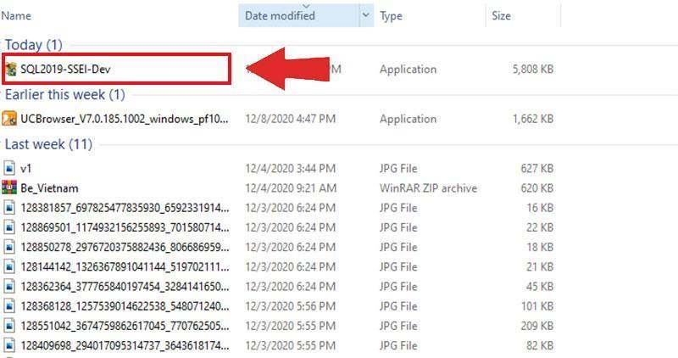

**Step 3:** After opening the application, we have 3 options depending on different purposes for the user:

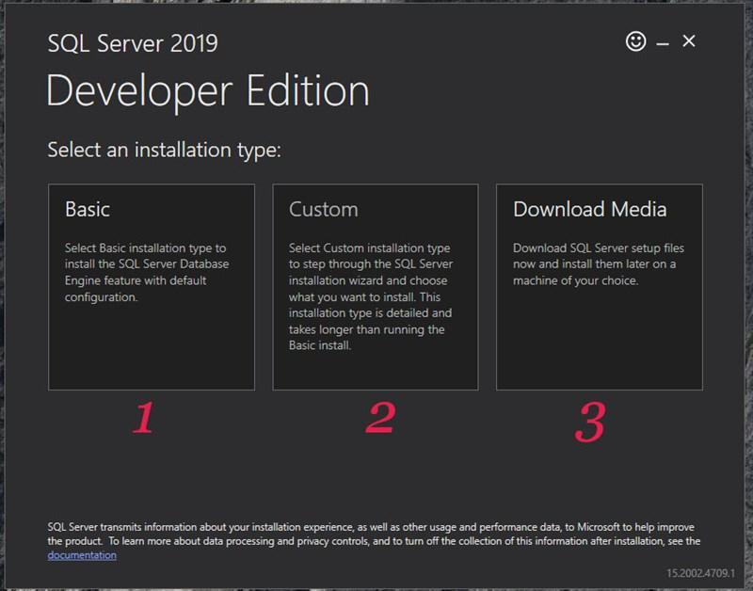

1. **Basic**: This is the simplest option for users, where the application will automatically install basic functions for you.

2. **Custom**: This is the installation section for those who want to use it more in-depth. When choosing, you will be able to install the software configuration yourself.

3. **Download Media**: When selecting this item, the system will download an offline installation file for you to install on many different devices without having to reload from the beginning.

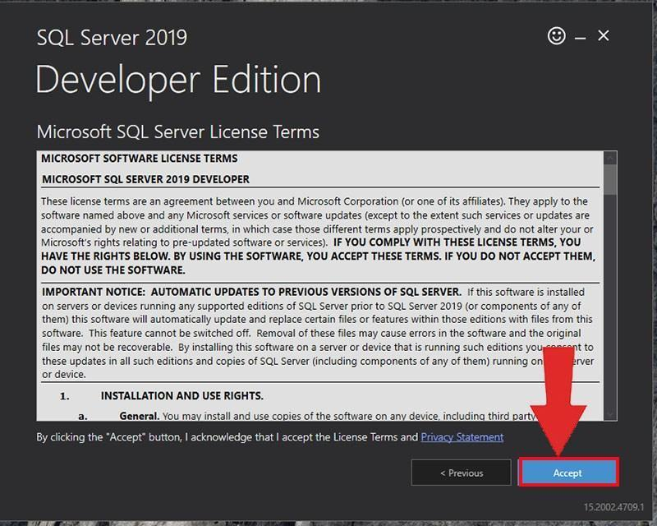

Please select basic and press Accept then press the Install button to proceed with the installation.

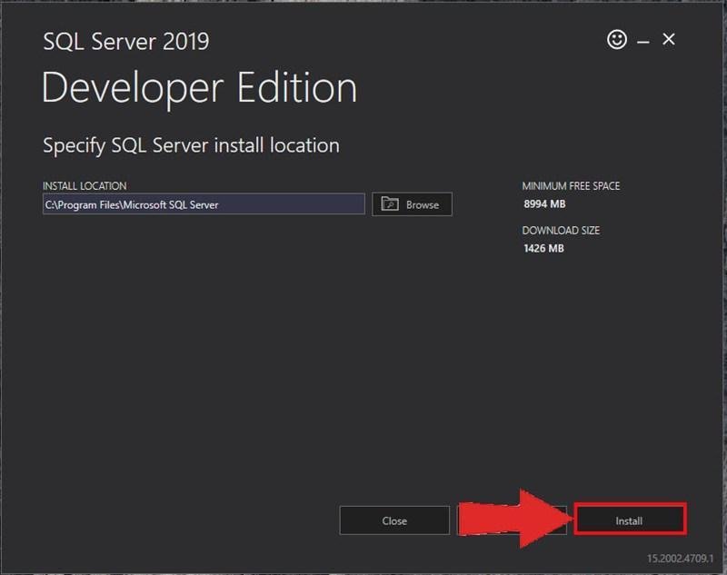

## 6. Download Github and clone Project

After install Github Desktop in web : <https://desktop.github.com/download/>

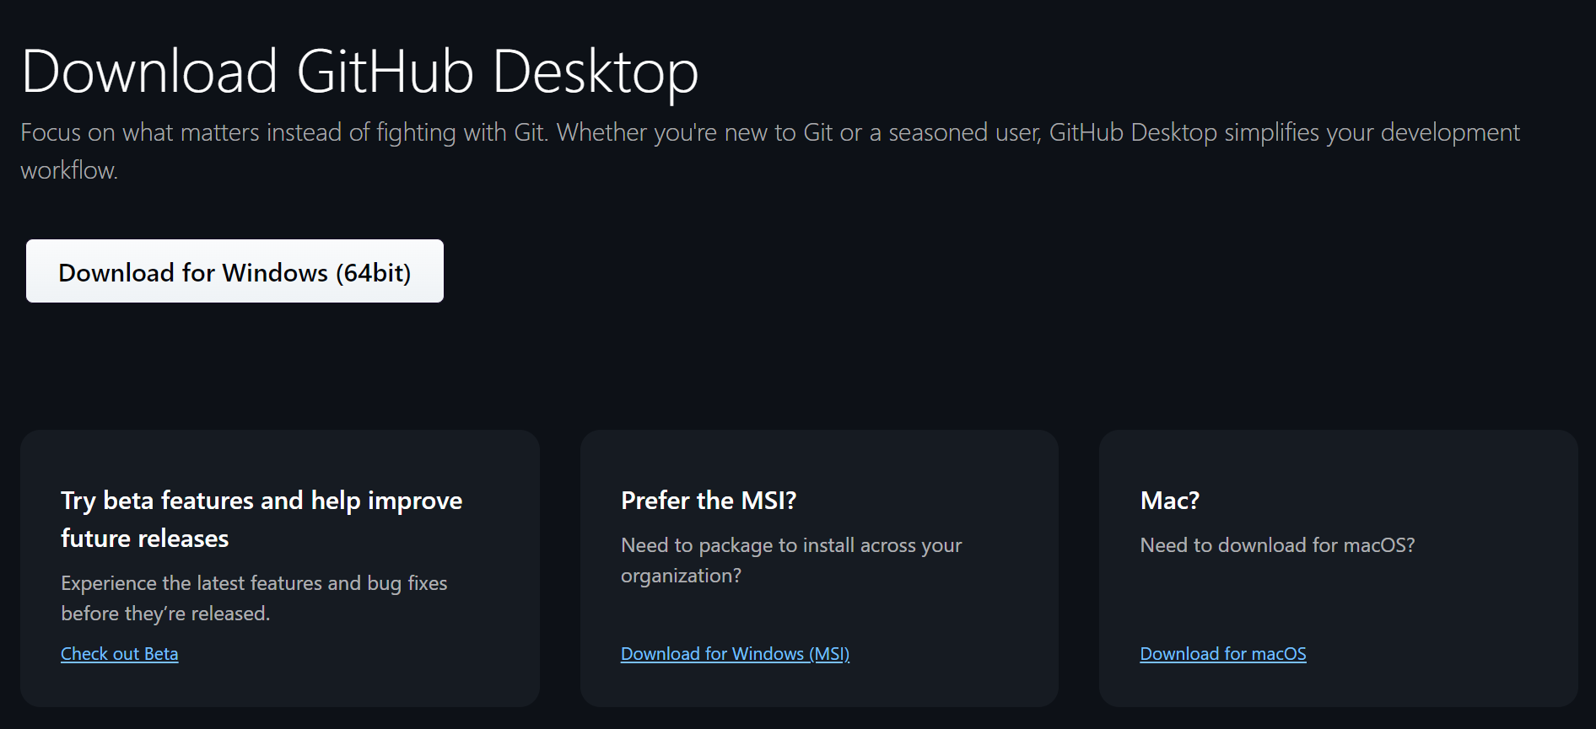

*Run it and click File -> Clone Repository with my link github project(https://github.com/swp-se1817-g5/FootballBookingTicket.git)*

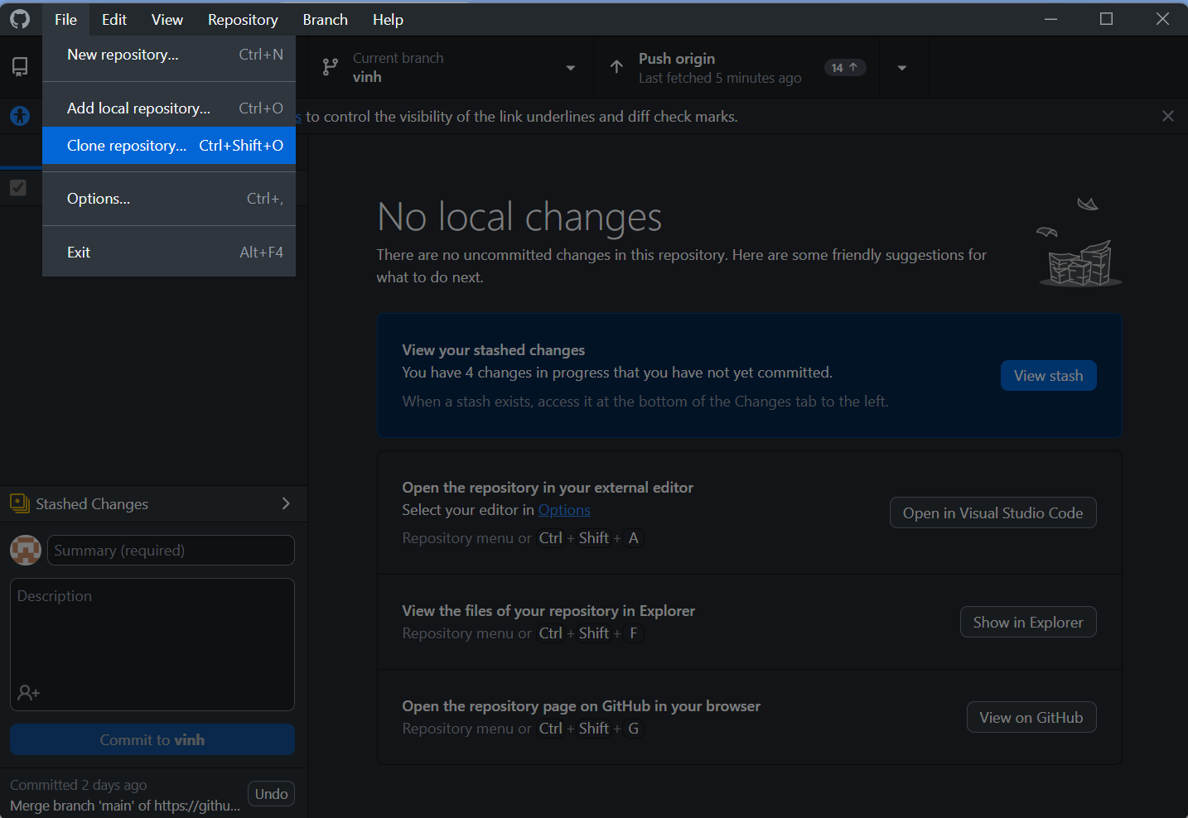

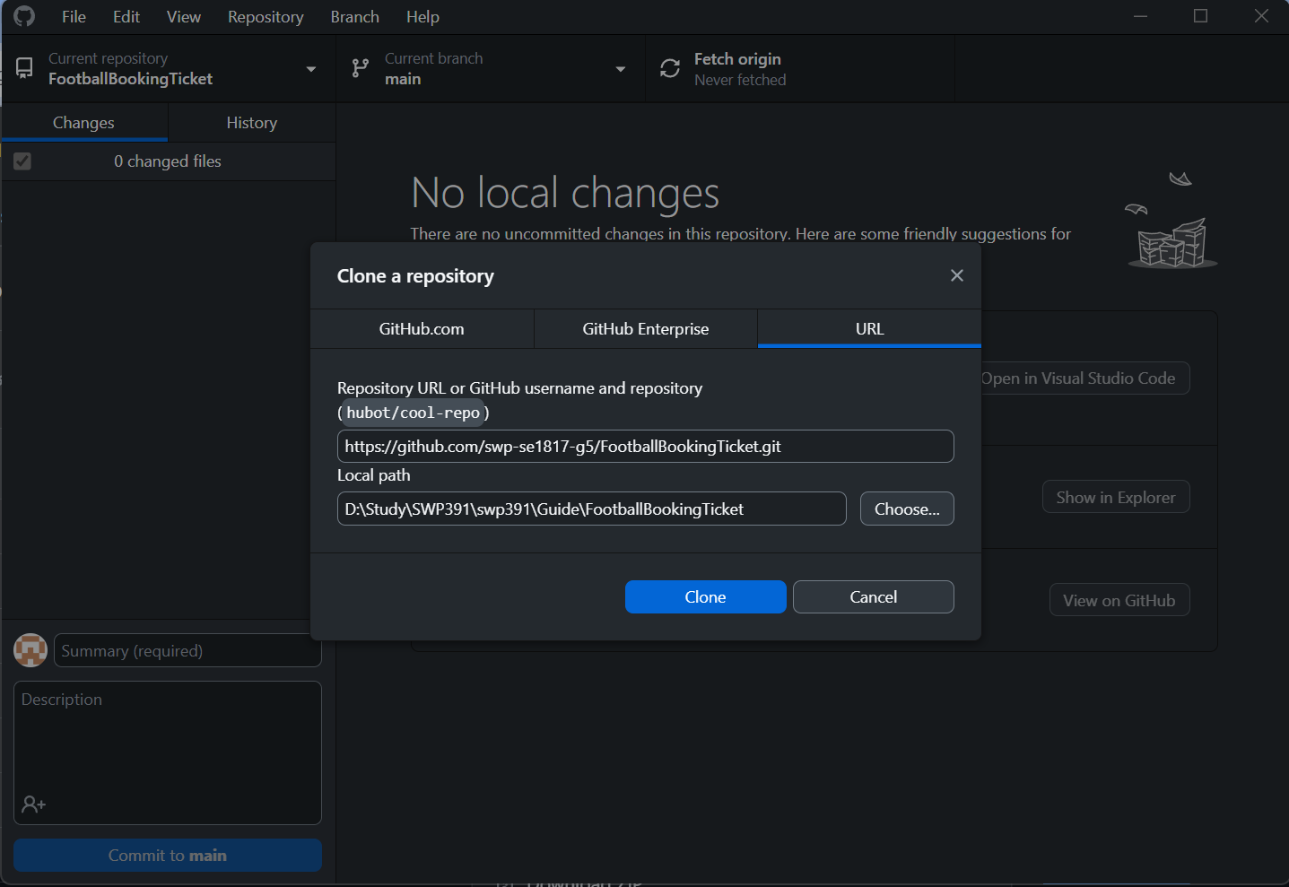

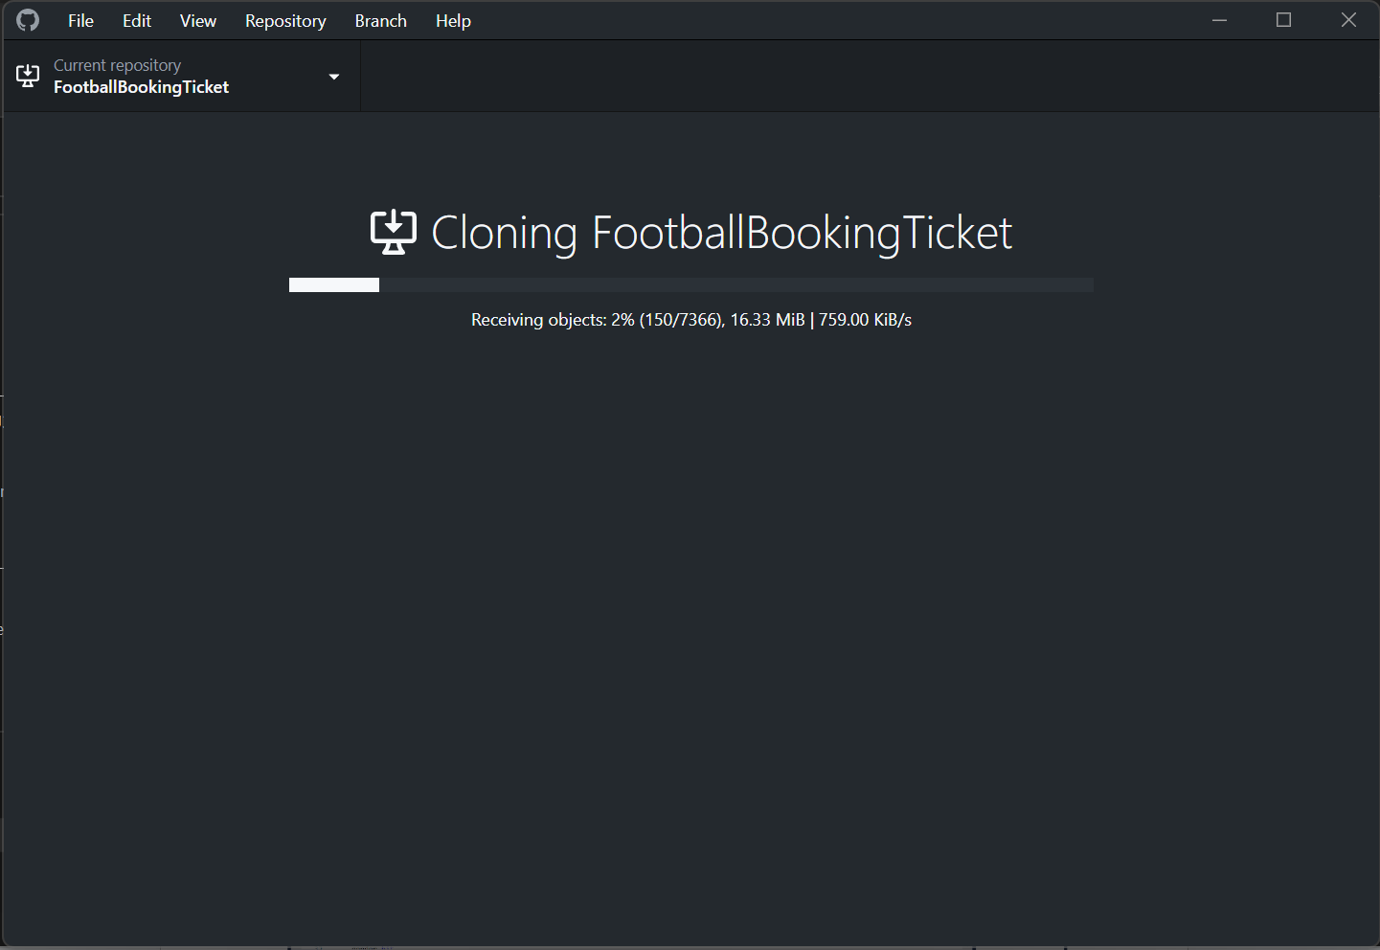

7. Run Database

Open file sql_script and all file SQL with SQL Server 2019 (double click to file SQL)

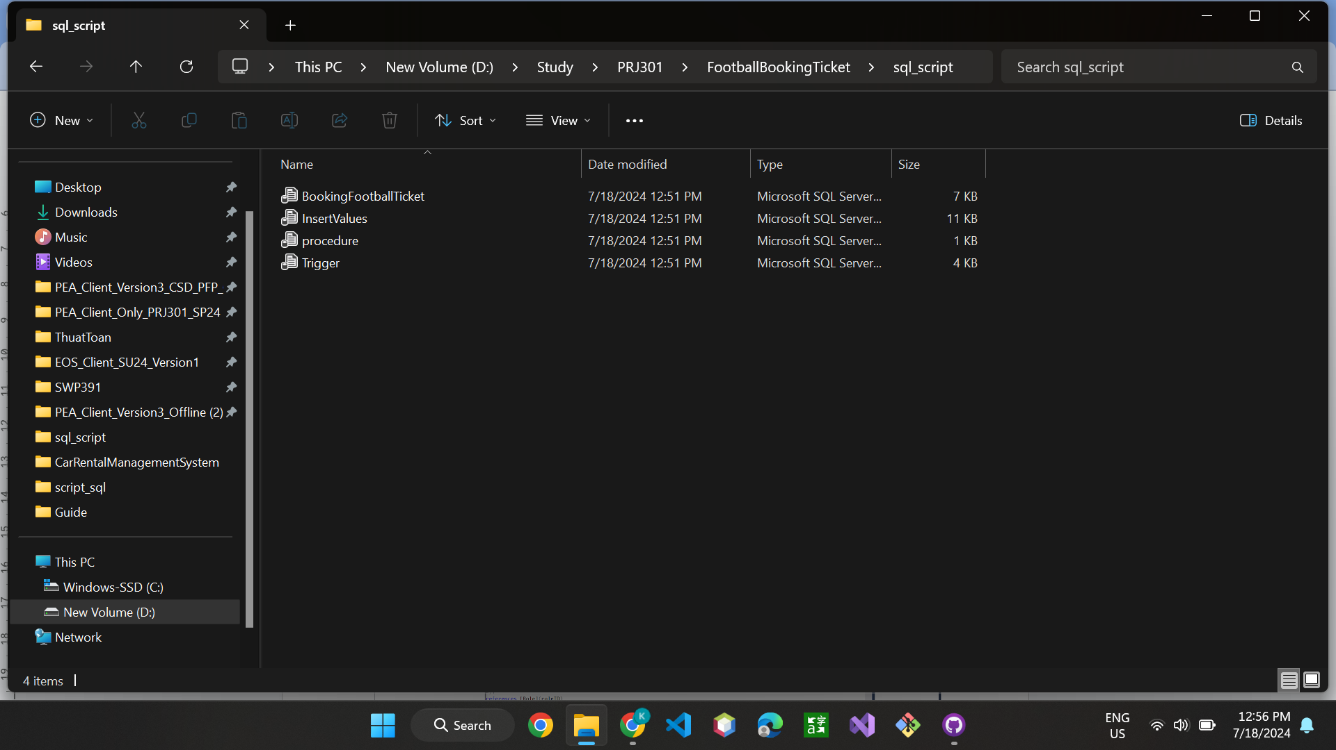

*Choosing window authentication and click connect.*

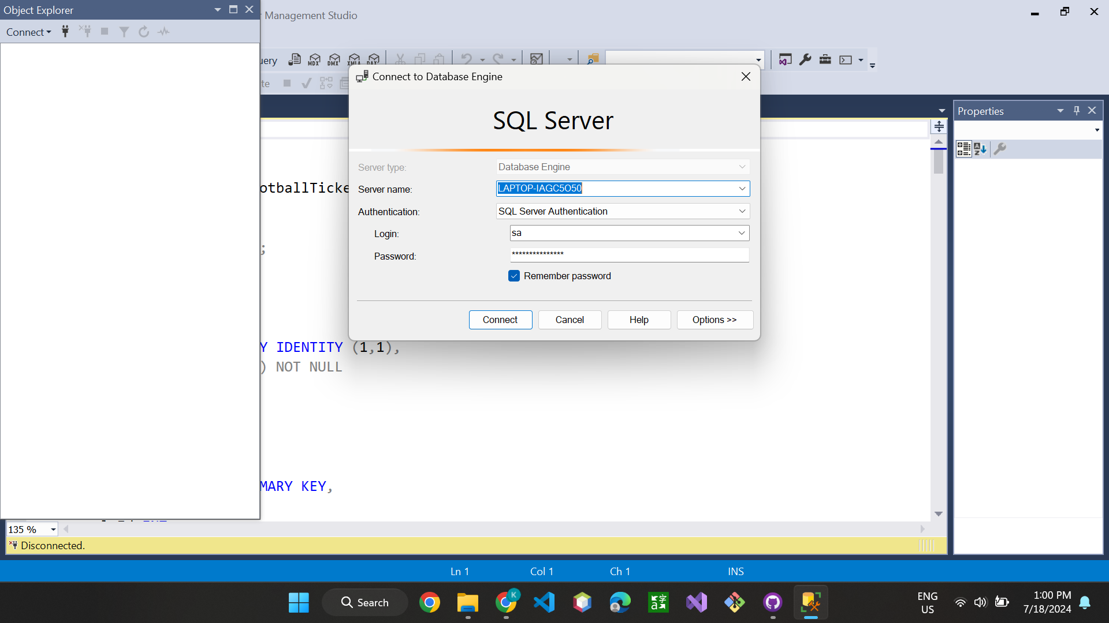

*Select Execute on the toolbar*

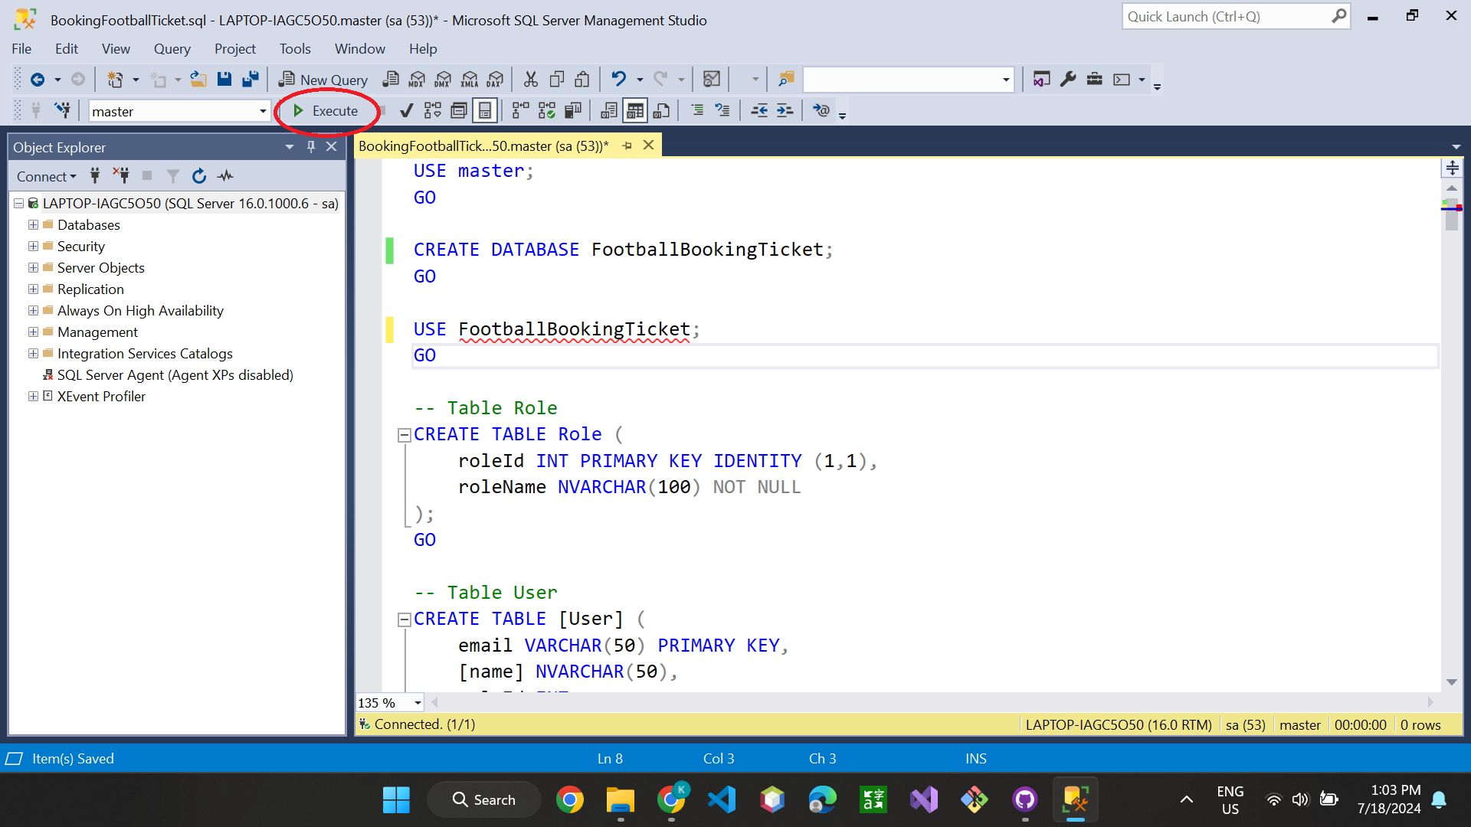

*After running, The database is created*

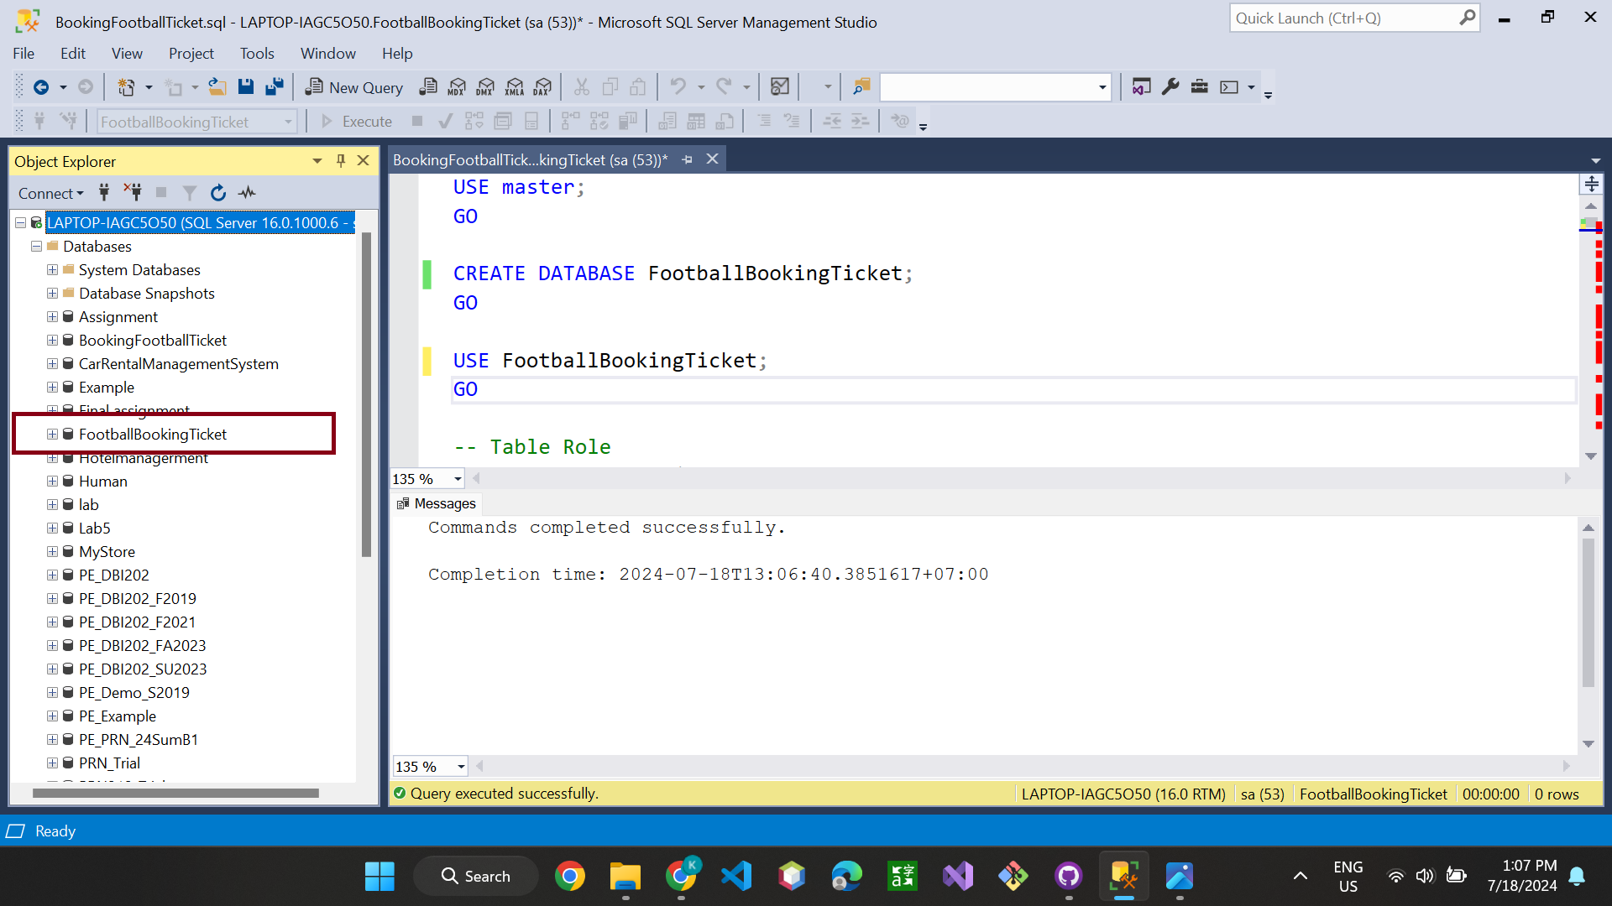

## 7. Open Project with Apache Netbeans IDE 17

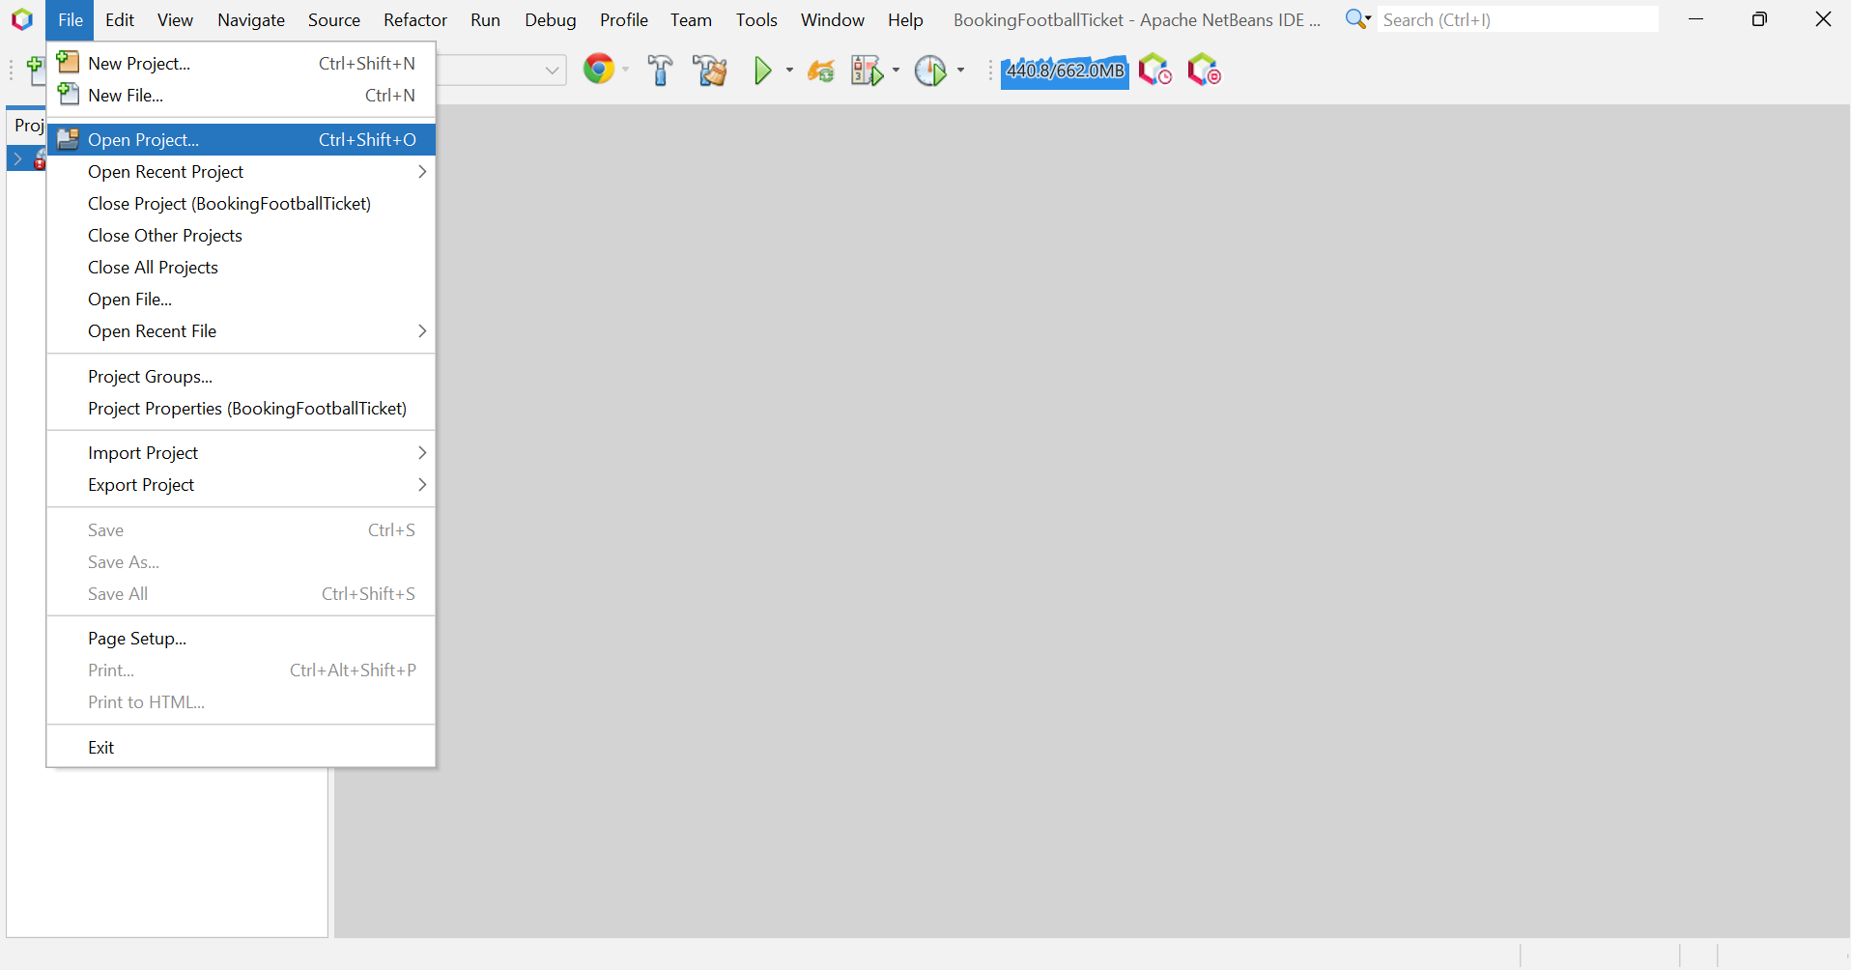

*Next, point to the project location and open*

After opening, we will see the project as follows

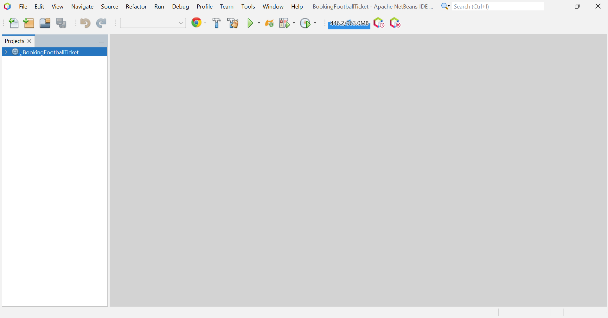

*Right-click on the project and select run*

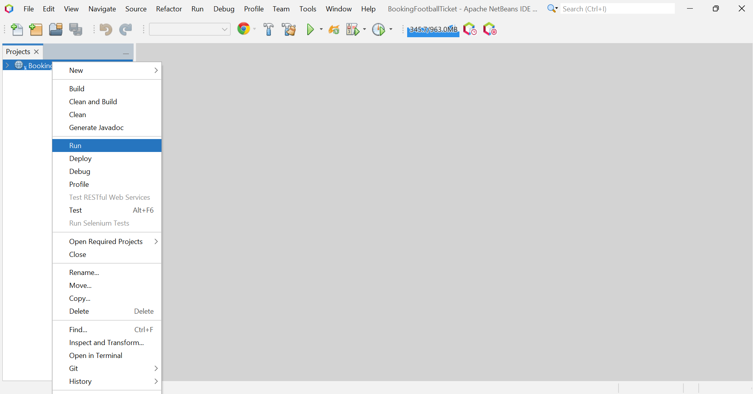

*After running project, the project will run on Chrome as follows*

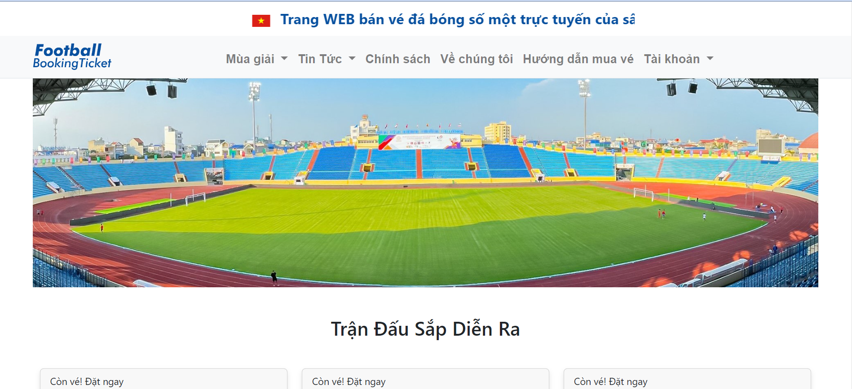

# III. User Manual

## 1. Overview

The Football Booking Ticket website is crafted to serve customers looking to buy football tickets specifically for My Dinh Stadium conveniently and efficiently. Our platform provides a wide range of tickets for upcoming thrilling matches, enabling customers to easily reserve their seats. Featuring a user-friendly interface, individuals can easily explore the site to locate tickets for their preferred teams and stay informed with daily updates. We give top priority to the security of our customers' transactions, guaranteeing a secure and dependable booking process through VNPAY. Administrators can effectively oversee and access team rosters, tournaments, news, matches, and revenue statistics through matches. Overall, the Football Booking Ticket website aims to be the ultimate destination for football fans seeking to purchase tickets for My Dinh Stadium, delivering a smooth and pleasant booking journey from beginning to end.

## 2. Purchasing Operations

Customer's purchasing process

The user will log in to the system. If the user does not have an account, he or she can click SignUp to register an account

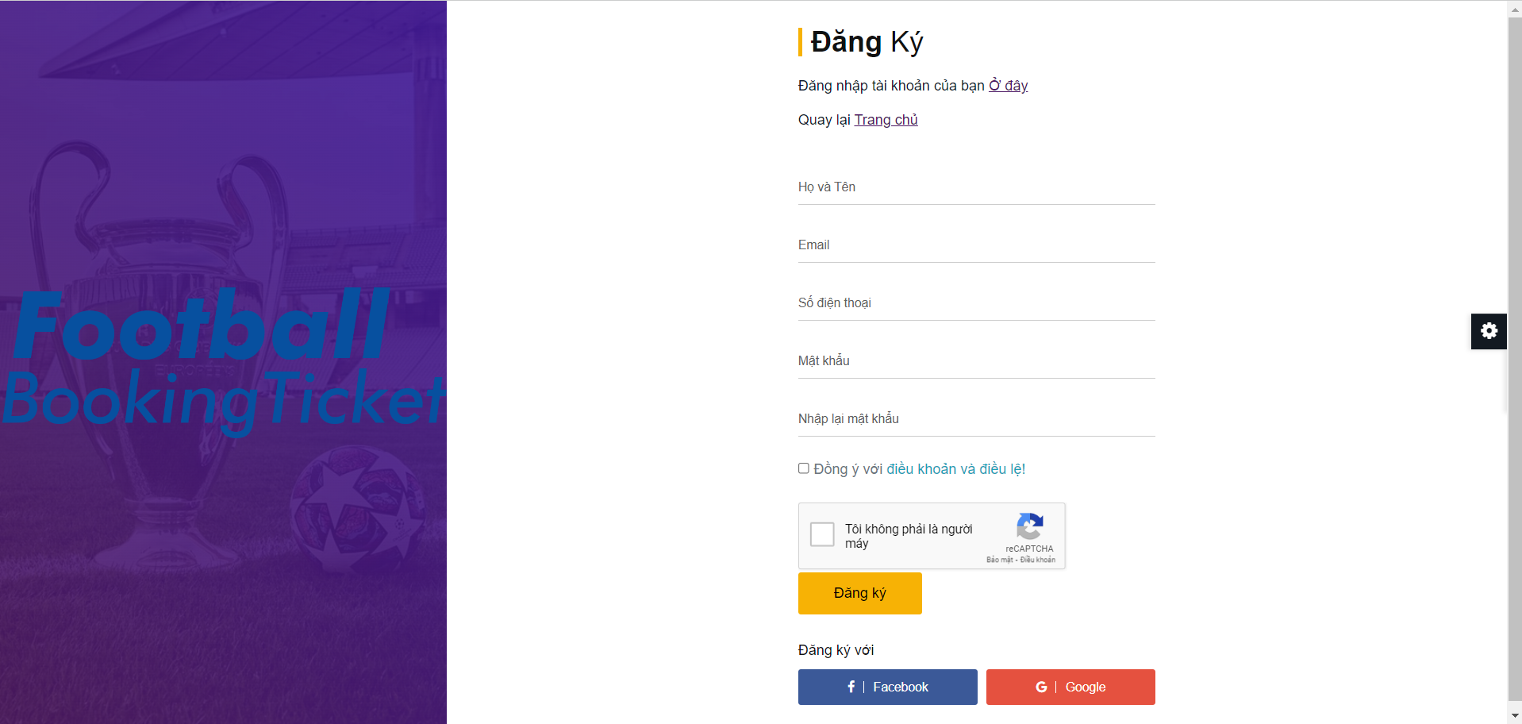

*When the user goes to the match list page, the user can choose any match*

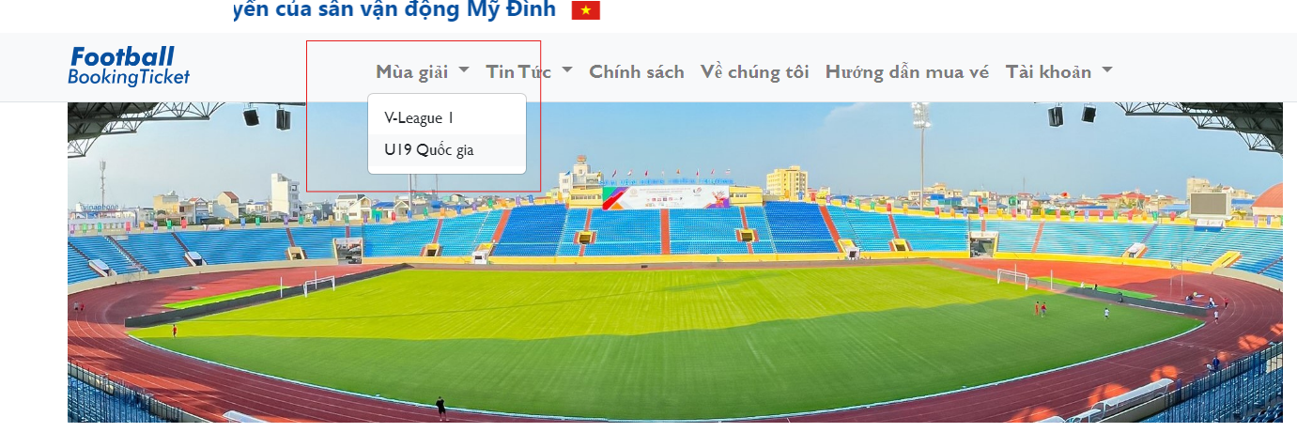

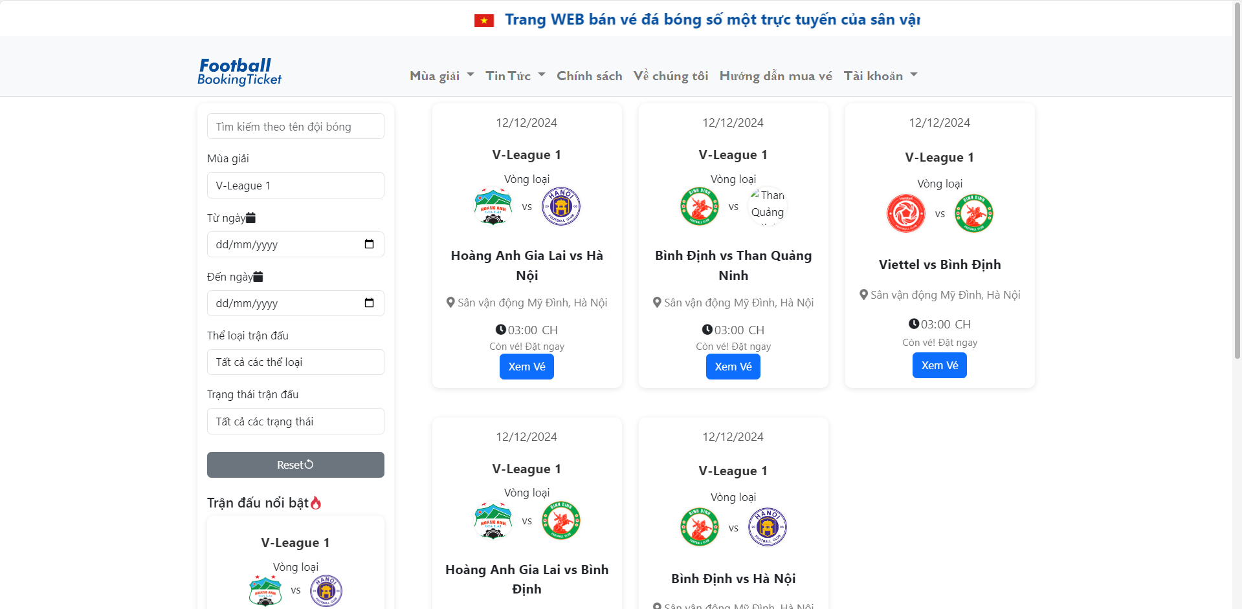

*After the user selects the match, they will go to the match details page. Here users can filter by seat in the stadium map on the left side of the page. The list of ticket seats will display corresponding to the user’s selection.*

*Users can set quantity(maximum is 5 for each order) and process to the summary page.*

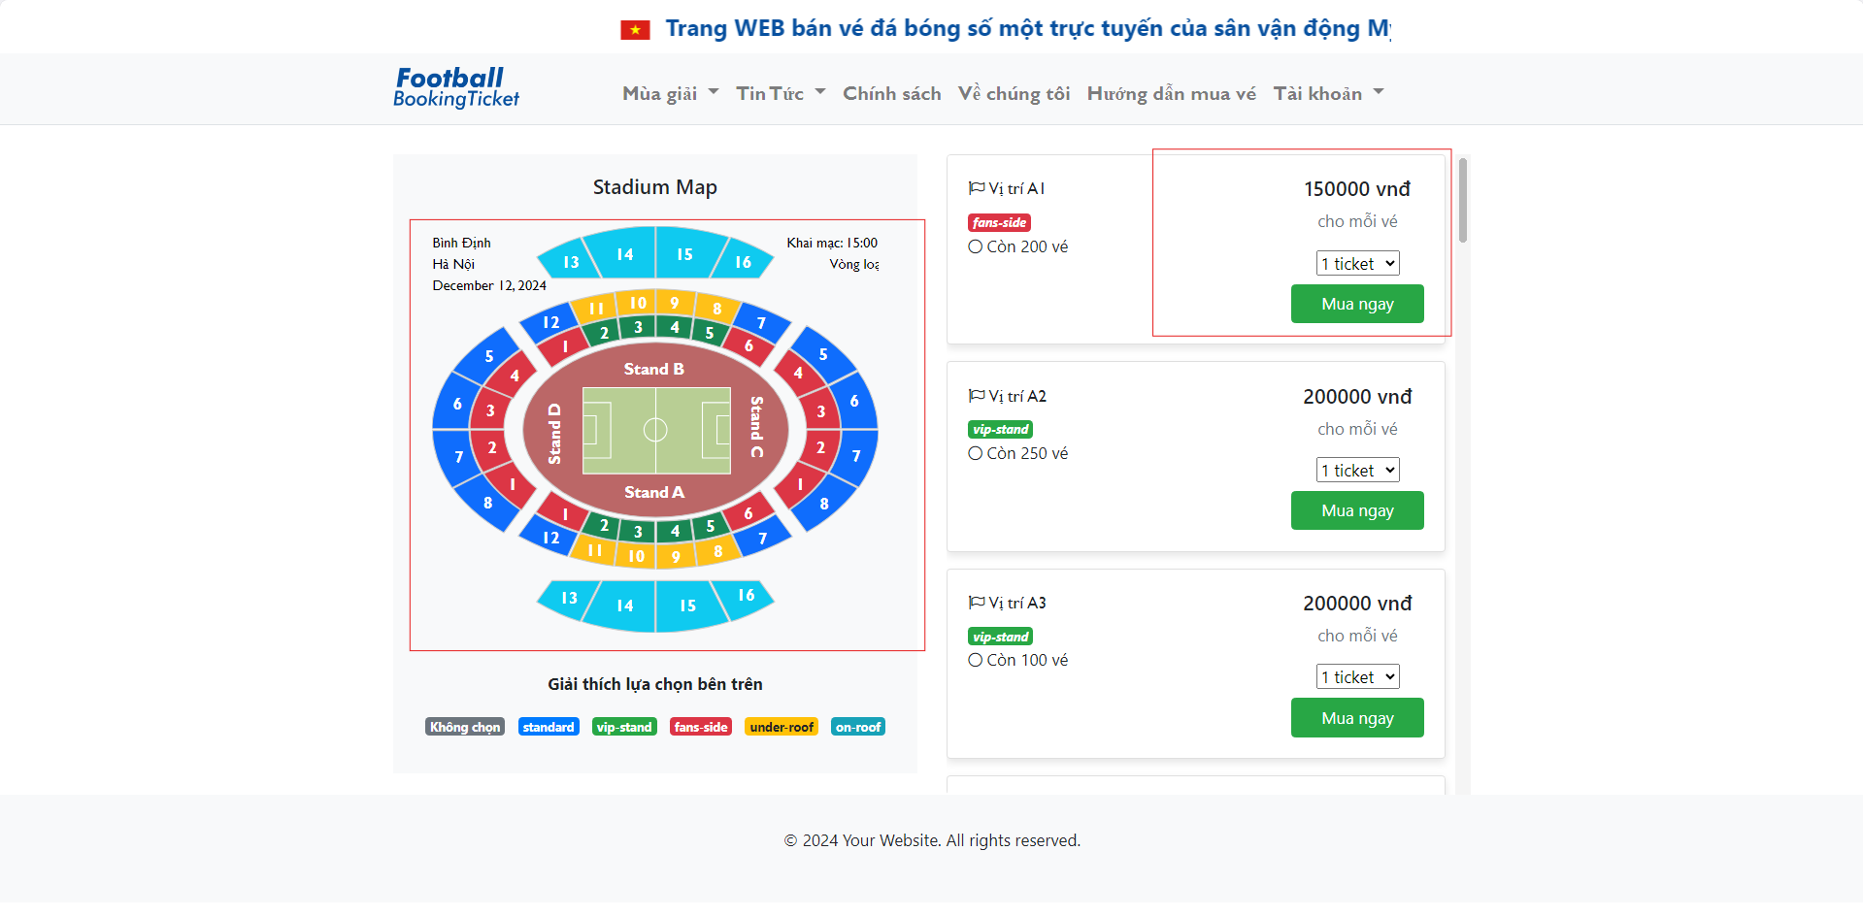

*Users fill in names and phone numbers and check the information of the order.*

*Users must agree to the terms and conditions to continue payment. Users click on “Thanh toán” to go to the Summary Order Ticket page*

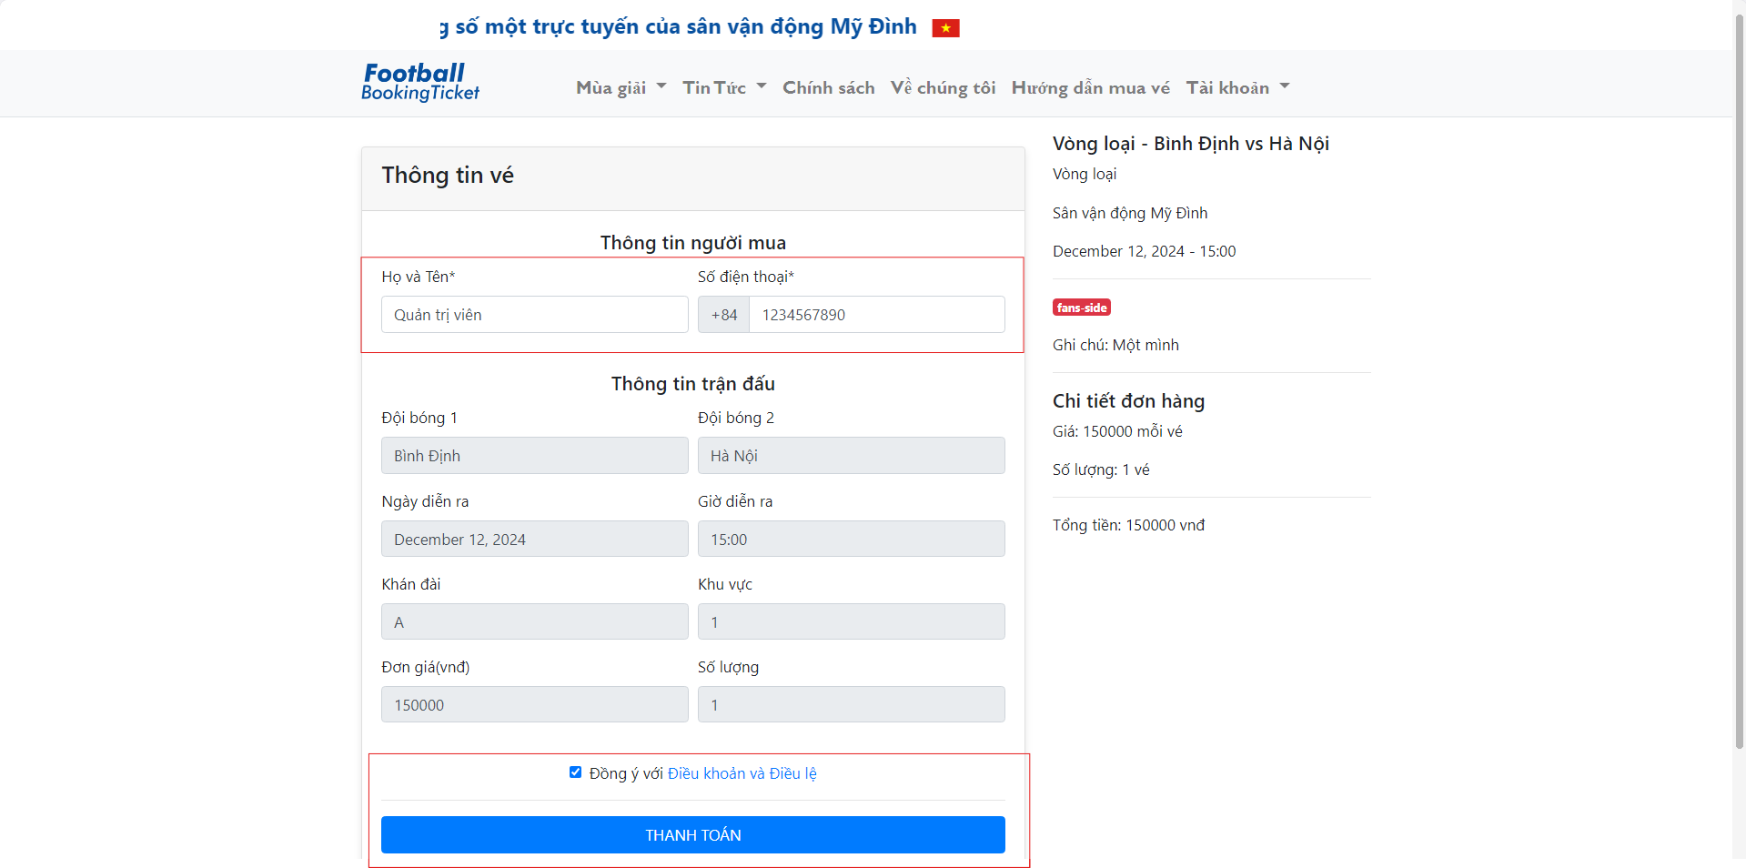

*The user selects a payment method.*

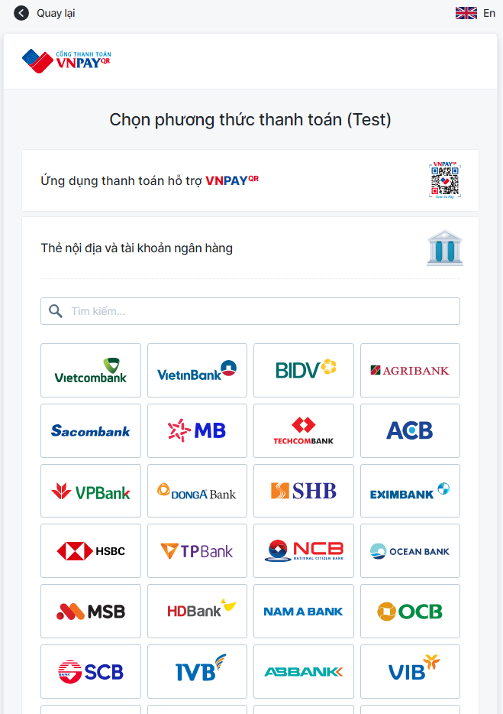

*Users must enter complete information and make payment before the transaction expires.*

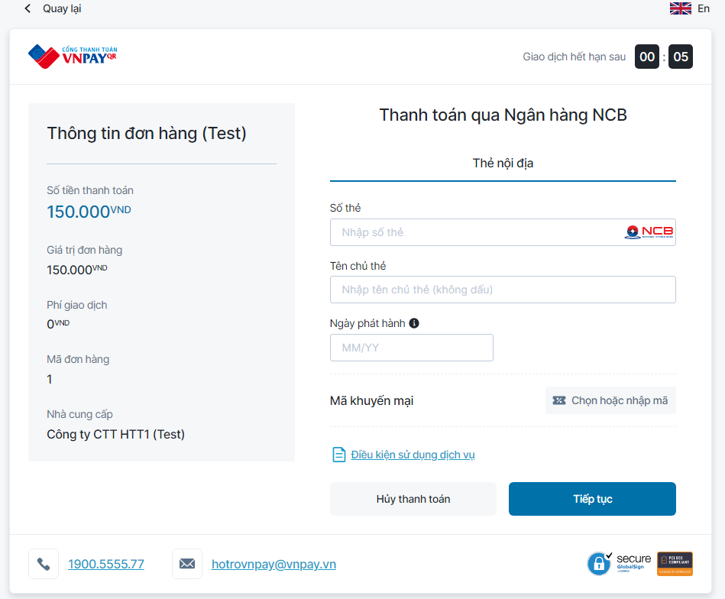

*After the user fills in valid information, the payment will be successful, the ticket will be added to the wallet. The user will be returned to the main homepage.*

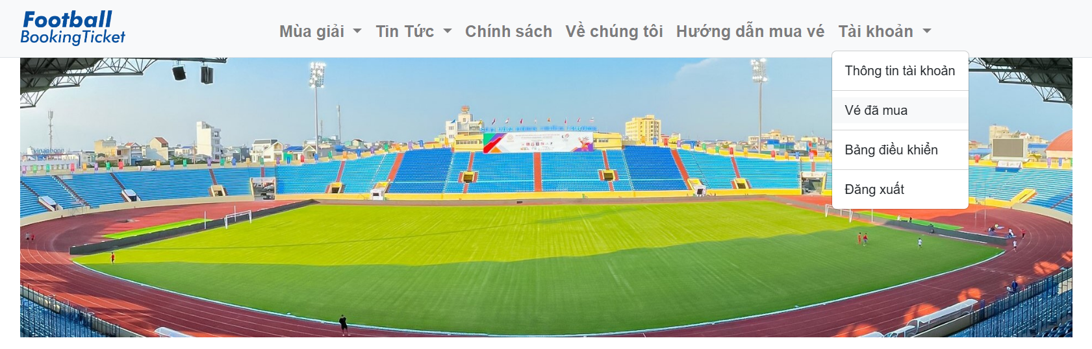

*User click on “Vé đã mua” to view tickets that have been purchased*

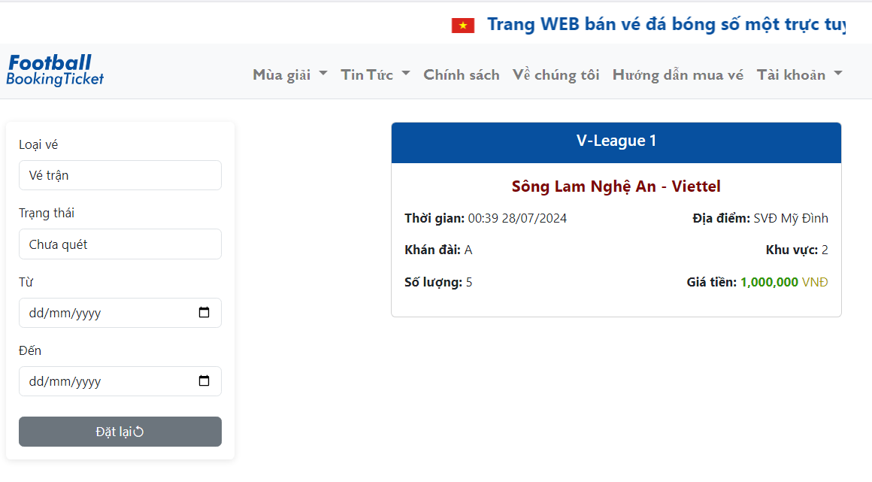

*Here, the system displays tickets that were purchased by the user and the user can find tickets by the filter on the left. Users can click on the ticket to view the details.*

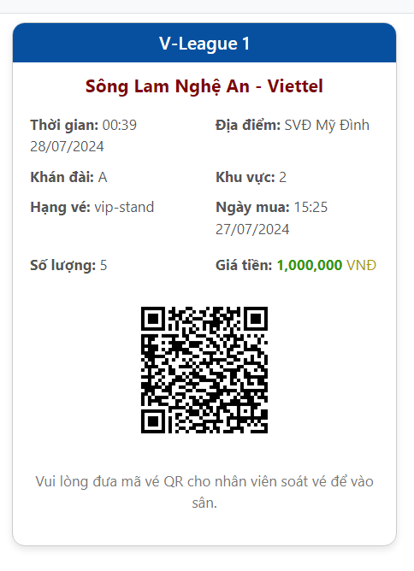

*This is detailed information on the ticket, it contains a QR code that is provided to the ticket inspector for scanning and checking the ticket so that the ticket inspector can approve the user's ticket to go inside the stadium.*

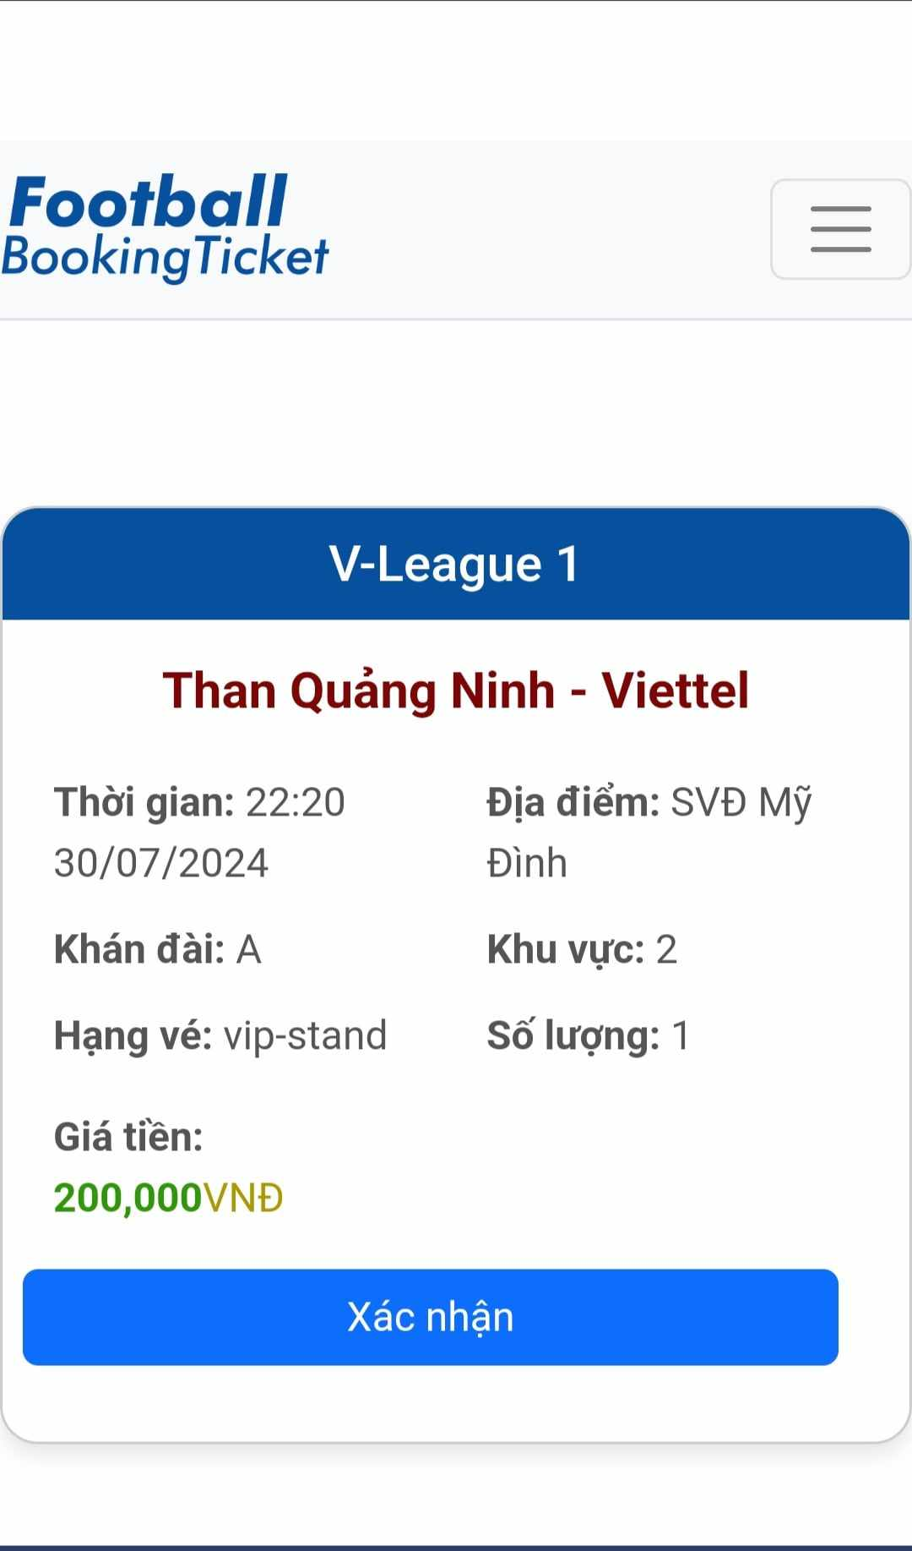

*After the ticket checker scans the ticket, the ticket information will be displayed on the display screen. And the ticket scanner can press the button to confirm the ticket, the ticket status will be returned after pressing confirm.*